**University of Colombo, Sri Lanka**

**Faculty of Technology**

**IC2301 – Multimedia and Web Design**

**Web Designing Assignment**

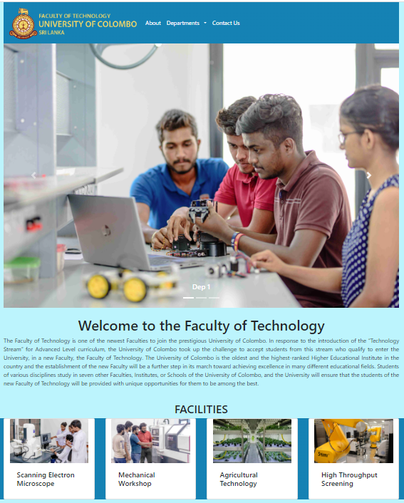

**<SECOUND YEAR SECOUND SEMESTER >**

**<H.G.RASAN DILIKSHANA>**

**<2019T00439>**

**<27/02/2023>**

HOME PAGE

LOGO

TEXT

TEXT

TEXT

TEXT

TEXT

TEXT

TOPIC

TOPIC

TOPIC

TOPIC

TOPIC

TEXT

HEADER

TEXT

LOGO

TEXT

TEXT

TOPIC

|  |  |  |  |
| --- | --- | --- | --- |
|  |  |  |  |

BUTTON

BUTTON

BUTTON

BUTTON

DEPARTMENT OF AGRICULTURE TECHNOLOGY PAGE

TEXT

TEXT

LOGO

TEXT

TEXT

TEXT

HEADER

TEXT

LOGO

DEPARTMENT OF ENVIRONMENTAL TECHNOLOGY PAGE

TEXT

TEXT

LOGO

TEXT

TEXT

TEXT

HEADER

TEXT

LOGO

DEPARTMENT OF INFORMATION AND COMMIUNICATION TECHNOLOGY PAGE

TEXT

TEXT

LOGO

TEXT

TEXT

TEXT

HEADER

TEXT

LOGO

DEPARTMENT OF INSTRUMENTATION AND AUTOMATION TECHNOLOGY PAGE

TEXT

TEXT

LOGO

TEXT

TEXT

TEXT

HEADER

TEXT

LOGO

ABOUT PAGE

LOGO

TEXT

TEXT

TEXT

TEXT

HEADER

TEXT

TOPIC

TEXT

TEXT

TOPIC

TEXT

LOGO

SCANNING ELECTRON MICROSCOPE PAGE

LOGO

TEXT

TEXT

TEXT

HEADER

TEXT

TEXT

LOGO

TEXT

MACANICAL WORKSHOP PAGE

LOGO

TEXT

TEXT

TEXT

HEADER

TEXT

TEXT

TEXT

LOGO

HIGH THROUGHPUT SCREENING PAGE

LOGO

TEXT

TEXT

TEXT

HEADER

TEXT

TEXT

TEXT

LOGO

TEXT

CONTACT US PAGE

LOGO

TEXT

TEXT

TEXT

HEADER

TOPIC

Text

Text

Text

Text

Text

Text

TOPIC

Text

TEXT

TEXT

LOGO

1. **Wireframe sketches of the User Interfaces (Above)**
2. **Why used <Dreamweaver/ Figma/ XD> to design this website.**

I used Dreamweaver that is a website creation program and that software allow to build and publish web pages almost anywhere with software that supports HTML, CSS, JavaScript and more.

We can use predefine elements, components without programming knowledge.

1. **Pros and Cons of using the above-mentioned web design technique**

**Adobe Dreamweaver**

|  |  |
| --- | --- |
| **Pros** | **Cons** |
| It highlights your coding so that it can be quickly scanned | Adobe Dreamweaver isn’t browser-based |
| It helps beginners understand what the coding does for a website | It takes time to learn the interface |
| Users receive code suggestions | Global styling can become a major headache |
| We don’t have to switch screens | All the many, many paragraphs in our code |
| Our coding is instantly checked | Most users aren’t going to need a system that is this comprehensive |
| Creating content variations is easy thanks to a word processing interface | Our automatic coding options are non-specific |
| Users can tab through files like someone tabs through internet sites | It actually encourages people to learn how to code |

1. **Briefly describe your web designing process that includes problems you faced and solutions you found for those problems.**

* Dreamweaver software does not prefer to the small display laptops.

The interface is difficult to work with because it splits into two sides.

Because of a small screen, the NAV Bar appears as a drop box

After I used big screen for design this.

* Sometimes & marks doesn’t appear.

When pasting paragraphs in the code, the & sign is not Add.

That problem is avoided when pasting the paragraphs in the Visual Interface.

* Sometimes styles were not added.

Didn’t work selectors.

1. **Further development. What do you think you need to add more to make your web design make it attractive and professional looking?**

* Attractive Colours
* High-Quality Images
* GIF
* Hyperlinks
* Infographics
* Short Videos
* Easy-to-read fonts
* Motions
* Transitions